Date 08/22/2024 Current price: $77.23 (08/22/2024) NYSE: WMT Headquarters: Bentonville, 702 SW 8th St, United States

Executive Summary
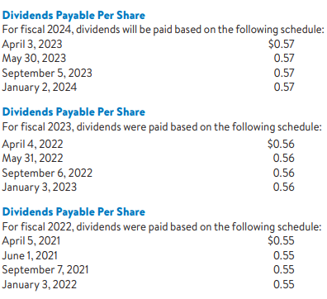
Walmart Inc., a global retail powerhouse, has consistently demonstrated robust financial results and strategic growth through the implementation of innovation and technology. Key features include leveraging AI and machine learning to enhance operations and enhance consumer interactions. Walmart has continued to see steady growth in revenue by staying dedicated to controlling costs, as demonstrated by its strong competition with industry leaders like Amazon and Costco. In order to enhance growth and maintain a competitive edge, strategies should involve expanding e-commerce functionalities, incorporating AI in various business segments, and enhancing sustainability initiatives.
Highlights
During CES 2024, Walmart's CEO, Doug McMillon, discussed the company's strategy of adaptive retail and the use of generative AI to improve customer experiences and business operations. He stressed the significance of prioritizing humans in technology investments. Generative AI Assistant: Walmart has launched 'My Assistant', an AI assistant, to 50,000 campus associates and is expanding its availability to countries like Canada, Mexico, and Chile. AI in Supply Chain: Walmart's Global CTO Suresh Kumar explained the use of AI in the company's supply chain, such as a cutting-edge forecasting system that anticipates customer actions and aids in precise product demand projections. Innovations in Customer Experience: Walmart is creating AI search tools, virtual try-on features, and personalized replenishment algorithms to enhance customer satisfaction. They also brought up a collaboration with Wing and Zipline to provide drone delivery to a large portion of the Dallas-Fort Worth community.
Recent News
Walmart+ has collaborated with Burger King to introduce a new dining perk, providing members with a 25% discount on digital orders and a complimentary Whopper every quarter, boosting the benefits of its membership program.
Walmart is introducing a new logistics service called Walmart Cross Border to simplify the import process for sellers, enabling full-container load shipments from Asia to U.S. facilities as part of its logistics expansion.
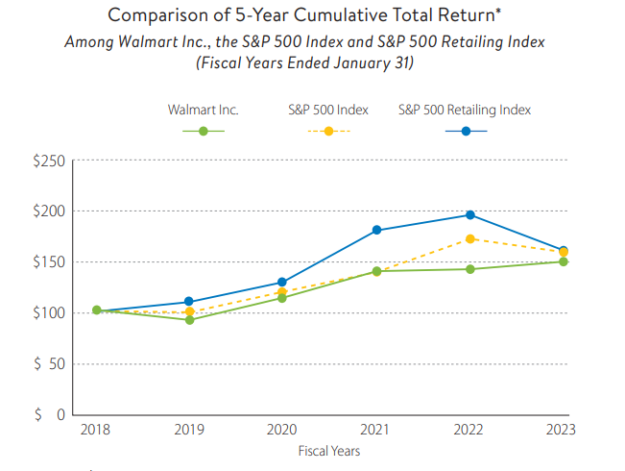
Walmart is increasingly focusing on environmental, social, and governance (ESG) efforts, with its Chief Sustainability Officer stating that ESG is integrated into operations and business strategies​.
Business Description
Walmart Inc. is a well-known retail company with a global presence, based in Bentonville, Arkansas, USA. Established by Sam Walton in 1962, the business has expanded to become the biggest retailer globally in terms of revenue, catering to over 255 million customers on a weekly basis through more than 10,500 stores in 19 countries. Walmart functions with three main business divisions: Walmart U.S., Walmart International, and Sam's Club. The main goal of the business is to assist individuals in saving money and improving their lives by providing a diverse range of products such as groceries, clothing, electronics, and household items, all at affordable prices. Walmart has been leading in retail innovation by using technology to improve its eCommerce capabilities and simplify its supply chain operations. With Walmart's fiscal year 2024 revenues exceeding $648 billion, the company remains a strong presence in the worldwide retail industry.
Corporate Governance:
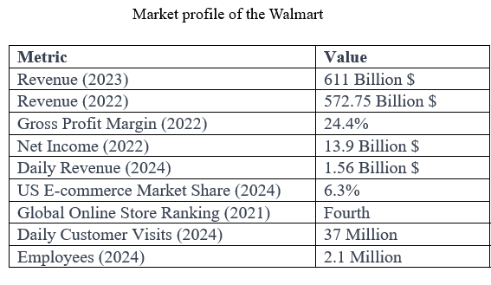
Walmart's corporate governance is characterized by a diverse and independent Board of Directors, with a clear separation of the Chair and CEO positions since 1988, and a Lead Independent Director position since 2004.
Structure of the board:
Walmart has had a strong and independent Board of Directors with separated Chair and CEO roles since 1988, which defines its corporate governance. This organization encourages autonomy in leadership and impartial decision-making, guaranteeing an equitable sharing of authority. The Lead Independent Director position, created in 2004, strengthens the board's supervision and responsibility.
Operations of the committee:
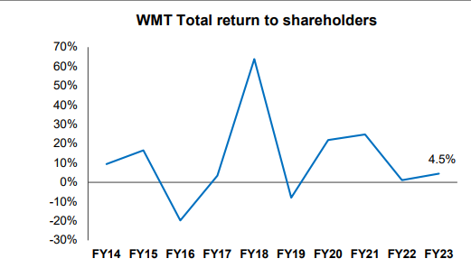
Walmart possesses six active committees that offer concentrated supervision on important areas: Strategic Planning and Finance, Technology and eCommerce, Audit, Compensation and Management Development, Nominating and Governance, and the Executive Committee. Every committee oversees certain governance aspects, like financial integrity, executive pay, and leadership growth, in line with Walmart's dedication to ethical business practices and social responsibility.
Engagement with stakeholders:
The Board of Directors actively interacts with shareholders to promote transparency and accountability in corporate decisions and strategies. This involvement guarantees that Walmart's governance procedures are in line with the desires of its stakeholders, strengthening the company's dedication to responsible and ethical practices.
Principles of morality in action:
Walmart is committed to maintaining elevated moral principles throughout every facet of its operations. The company places importance on following legal standards and encouraging ethical behavior in both its leaders and employees, making sure that all activities are carried out with integrity and accountability.

Research and Development
Walmart's focus on research and development is crucial for improving customer experiences, optimizing operations, and staying ahead in the retail industry. The company is promoting innovation in all areas of its business through investments in advanced technologies like artificial intelligence (AI), virtual and augmented reality (VR/AR), and robotics, which are utilized in tasks from inventory control to customer payment processing. Walmart's emphasis on sustainability has driven the company to embark on multiple green initiatives to reduce its ecological footprint. Through strategic partnerships and acquisitions, platforms into its operations, stimulating e-commerce expansion and broadening its sources of revenue. The company's research and development endeavours have resulted in a smoother omnichannel shopping experience, successfully integrating both in-person and digital interactions. Furthermore, Walmart has seen a significant improvement in personalized customer service and marketing through increased investment in data analytics, which has allowed for customized shopping experiences based on individual consumer preferences. By dedicating resources to research and development, Walmart remains at the forefront of the evolving retail industry, establishing itself as a pioneer in embracing innovative technologies to boost its expansion.
Financial Statements Analysis
An in-depth analysis of Walmart Inc.'s financial results between 2015 and 2024, examining important patterns and understandings. During this time, Walmart has shown resilience and flexibility, thanks to strategic investments in technology, sustainability, and global expansion. The financial review emphasizes steady revenue increase, operational effectiveness, and careful financial handling. Analyzing financial documents such as income statements, balance sheets, and important financial ratios helps us comprehend how Walmart has sustained its position as a market leader and preserved shareholder value for the long term.
Annual Income Statement:
During the past ten years, Walmart has steadily grown its revenue by expanding its e-commerce presence, making strategic acquisitions, and investing in technology. Revenue growth rates have fluctuated, particularly during years when Walmart increased its digital offerings and incorporated advanced technologies such as AI and automation operating expenses, Walmart has managed to keep a consistent gross profit margin, demonstrating effective cost control and taking advantage of economies of scale. Nevertheless, the profit margin has displayed fluctuations, influenced by investments in technology, infrastructure, and competitive pricing tactics to gain market share. Walmart's revenue growth is mainly driven by its efforts to improve the shopping experience across all channels, combine online and in-store activities, and use data analytics for personalized marketing and customer interaction.
Annual Balance Sheet:
Walmart's financial stability and strategic asset management are evidenced in its balance sheet between 2015 and 2024. A large part of Walmart's wealth is invested in property, plant, and equipment, reflecting its extensive physical retail locations and dedication to preserving its leadership in the market. Lately, Walmart has strategically shifted its attention towards technological resources, with significant investments in e-commerce platforms, digital infrastructure, and supply chain automation. This change highlights Walmart's proactive adjustment to the changing retail environment, where digital integration is essential for maintaining a competitive edge. Walmart has consistently optimized inventory levels to ensure products are available while minimizing holding costs, which has been a key feature of their operations. This method has increased available funds and maintained consistent growth in sales, even during times of economic instability.
Walmart has shown smart financial management on the liabilities side by using debt wisely to finance its growth strategies. This involves increasing its worldwide presence, improving its online shopping abilities, and funding innovative technologies. Even though Walmart has used debt to grow, it has kept a strong debt-to-equity ratio, managing its capital structure effectively to ensure lasting financial stability and easily handle its debt repayments.
The equity part of Walmart's balance sheet has experienced steady expansion, fuelled by strong retained earnings and capital appreciation. This increase shows Walmart's robust profitability and dedication to providing value to shareholders with dividends and share buybacks. Walmart continues to demonstrate strong capacity to meet short-term obligations as its liquidity ratios, like the current and quick ratios, remain in good standing. This financial freedom allows Walmart to handle economic changes and take advantage of growth opportunities when they appear. Moreover, Walmart's leverage ratios show a well-balanced utilization of debt, along with adequate earnings to cover interest payments, which strengthens the company's financial stability.
Financial Analysis of Walmart Inc. for Fiscal Years 2015–2024.
This financial assessment examines Walmart Inc.'s performance in the last decade, focusing on key indicators such as profitability, liquidity, leverage, efficiency, and asset management. During this time, Walmart has experienced fluctuations in its net profit margins, generally decreasing over time. Increased competition from brick-and-mortar stores and online platforms has likely led to this decrease, forcing Walmart to reduce prices and provide discounts to maintain its market share. Despite these difficulties, Walmart has managed to maintain a relatively consistent gross profit margin due to its successful implementation of cost-cutting strategies, including negotiating better deals with suppliers and improving efficiency in its supply chain.
Conversely, a drop in Walmart's operating profit margin indicates that expenses related to operations, such as labor, store upkeep, and logistics, are increasing more quickly than revenue. This may be due to Walmart's strategic initiatives to grow its online presence and enhance customer interactions, necessitating substantial investments in technology and e-commerce infrastructure, as well as increased labor expenses from higher wages. Walmart's rising debt-to-equity ratio suggests that the company is increasingly turning to debt financing to back its expansion into new markets and investments in technology in order to remain competitive against major e-commerce firms. Although this approach may support expansion, it also brings in more financial risk, so close monitoring is necessary to ensure the benefits from these investments are worth the risks involved. The existing current ratio, evaluating Walmart's ability to meet short-term financial obligations, has been decreasing, causing potential worries about the company's liquidity. This decrease could be connected to Walmart's assertive inventory management strategies, designed to ensure stores are well-supplied while reducing stockouts that may require additional working capital.
Even though Walmart still performs well in managing inventory, a small decrease in efficiency indicates there is potential for more improvements. The company must improve the alignment of its inventory levels with consumer demand patterns in order to avoid excess stock. Furthermore, the drop in fixed assets and total asset turnover suggests that assets are not being fully utilized, signaling a possible necessity to reassess the scope of store expansions and investments in technological infrastructure. Enhancing cash flow could also be achieved by improving the management of receivables through technological advances.
In brief, despite Walmart's dominance in retail, this financial review highlights the need to focus on margin pressures, improve operational efficiency, and be cautious with financial leverage. In order to succeed in a quickly changing retail landscape, Walmart may have to concentrate on additional investments in technology and e-commerce, streamline its inventory management procedures, and enhance asset utilization plans.

APPENDIX
